Sales data visualization

DATA

The tables contain the data on sales from 2017 to 2019, There are 20 products that are sold to different cities according to their requirements.

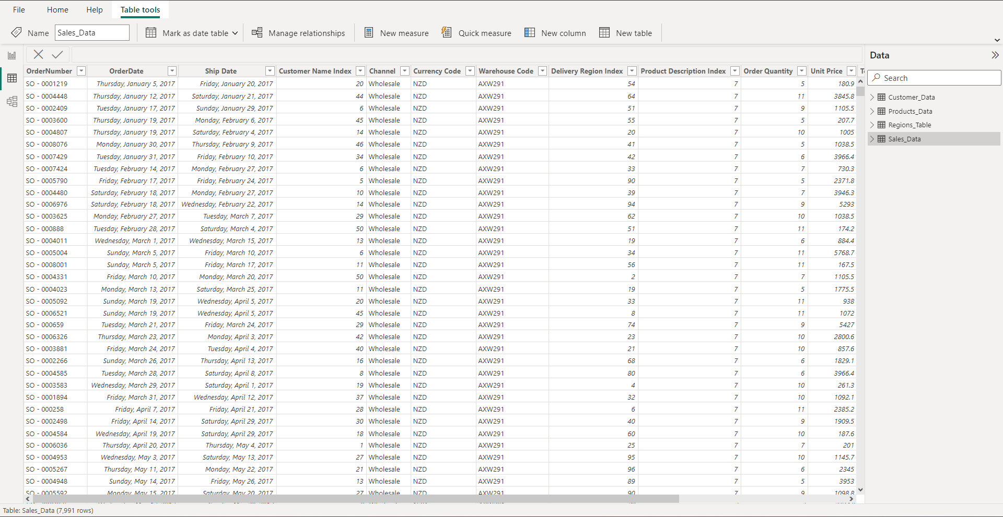

Here the data has been loaded into power bi for analysis and visualization, the data consist of four tables namely customer data, product data, regions data, and sales data in which the sales table contains the primary key of all other tables.

DATA – MODELING

The Model View in Power BI is utilized for data modeling, where the primary keys of all tables are linked together to enable in-depth analysis. By establishing relationships between tables based on their primary keys, you create connections that facilitate the combination and exploration of data across multiple tables. This approach allows for effective aggregation, filtering, calculation, and visualization of data, empowering users to gain valuable insights and answer complex business questions. The Model View provides a visual representation of these relationships, aiding in understanding the data model structure and enhancing the efficiency of data analysis and reporting processes.

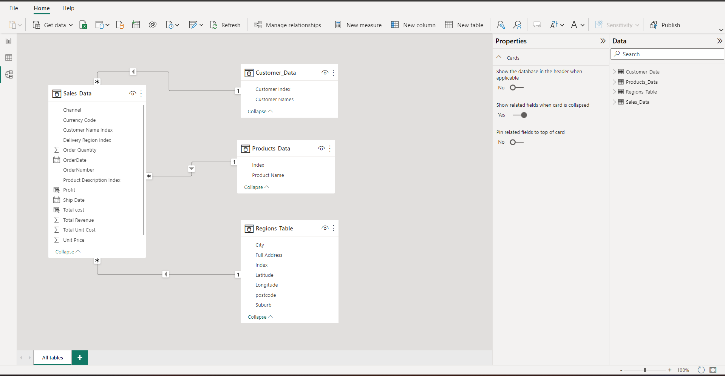

Here the "customer index" in the customer data is connected to the "customer name index" in the sales table and the "index" field in the product data is connected to the "product description index" in the sales table similarly the "index" field in the regions data is connected to the "delivery region index" in the sales table.

DATA – PREPROCESSING

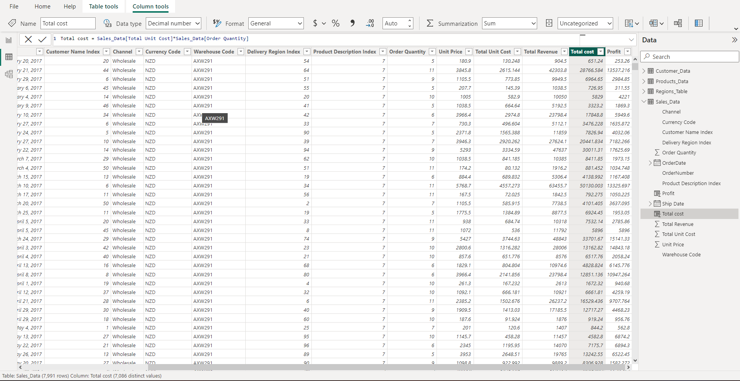

Here the "total cost" and "Profit" are the two new fields that have been calculated using power query.

DASHBOARD

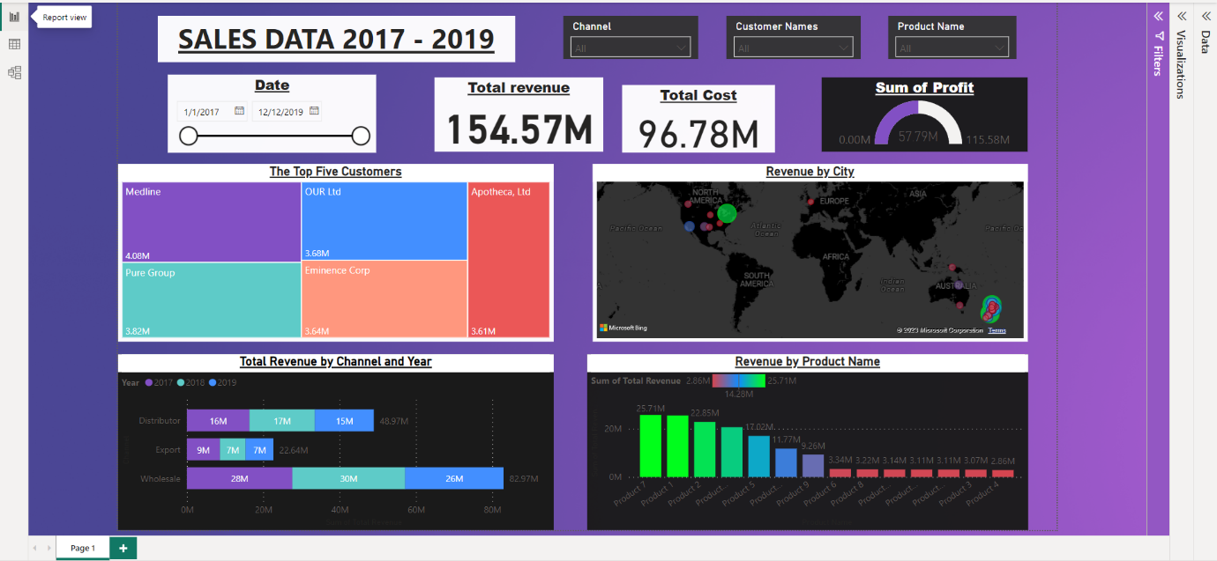

This dashboard depicts the entire data. with the three dropdowns, we could select any permutation and combination of the data, and the dashboard changes accordingly. The map visual in the dashboard represents the cities of potential clients and the revenue generated from each city.